 | Network Management 316R NMG316D  Practical Group Assignment  Deadline 11 May 2026
 | Assessment Due Date (During our Class Time)  1ST Semester |  |  |  | 1st Examiner:  Mr Z. Mapundu  2nd Examiner:  Mr NP Makondo
 | Hardcopy & Electronic Submission  11 May 2026 |  |  |  | External Moderator  Mr MI Mbasane
Student Signatures
 | Student Number
 | 2 | 2 | 4 | 3 | 7 | 0 | 4 | 1 | 5
 | 2 | 2 | 3 | 6 | 0 | 4 | 0 | 1 | 3
 | 2 | 3 | 0 | 3 | 4 | 4 | 2 | 9 | 9
 | 2 | 3 | 0 | 6 | 1 | 2 | 3 | 8 | 2
 | 2 | 2 | 4 | 0 | 3 | 2 | 6 | 6 | 8
 | 2 | 3 | 1 | 0 | 7 | 8 | 8 | 3 | 5
 | 2 | 2 | 3 | 5 | 7 | 3 | 3 | 6 | 3
 | 2 | 2 | 3 | 7 | 6 | 3 | 3 | 1 | 6
 | 2 | 2 | 1 | 0 | 3 | 7 | 6 | 7 | 7
 | 2 | 3 | 1 | 9 | 2 | 4 | 4 | 0 | 0
 | 2 | 2 | 1 | 5 | 7 | 4 | 7 | 4 | 5
 |  |  |  |  |  |  |  | %

Total | Paper Total | 100

SECTION A
Question 1
Topology Drawing
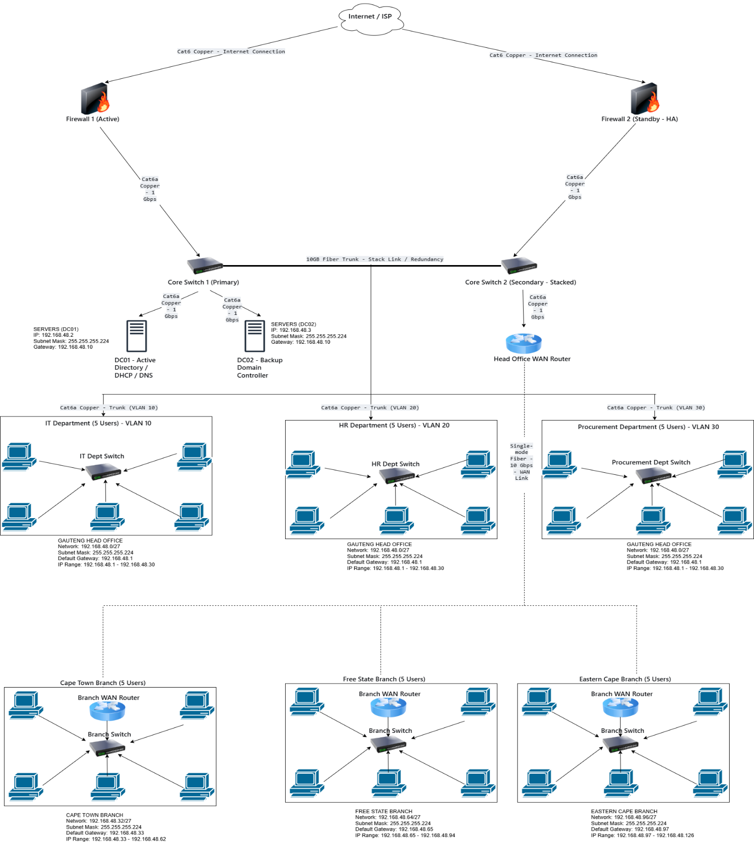

Introduction
The network topology was designed to provide secure, reliable, and efficient communication between the Head Office in Gauteng and branch offices in Cape Town, the Free State, and the Eastern Cape. The design supports centralized management, resource sharing, and future expansion.

Firewalls
Two Firewalls are used for network redundancy. Firewall 1 (Active) handles all internet traffic while Firewall 2 (Standby) monitors Firewall 1 through heartbeat signals. If Firewall 1 fails due to hardware failure, power loss, or software crash, Firewall 2 automatically takes over with zero downtime. This ensures that all branch offices maintain internet connectivity and secure communication with the Head Office.
Purpose:
- Protects the network from unauthorized access
- Prevents cyber-attacks and malicious traffic
- Ensures continuous internet connectivity for all branches

Core Switches
Two Core Switches are connected via a 10 G Fiber Trunk (Stack Link) to provide network redundancy. All servers, department switches, and WAN routers connect to both core switches. If one core switch fails, the second switch automatically continues carrying all network traffic without interrupting users.
Purpose is to:
- Connects all departments and servers
- Improves network performance
- Eliminates single points of failure
- Supports high-speed communication between devices

Domain Controllers (DC01 and DC02)
Two Domain Controllers are used for system redundancy.
- DC01 acts as the Primary Domain Controller
- DC02 acts as the Backup Domain Controller
Both servers replicate Active Directory information continuously. If DC01 fails, DC02 automatically handles: User authentication, DNS services, and DHCP services. Users can continue logging into the network without interruption.
Purpose:
- Centralized user management
- Automatic IP address allocation
- Name resolution services
- Fault tolerance and high availability

Head Office WAN Router
The Head Office WAN Router connects all branch offices to the Head Office using single-mode fiber cables. Fiber is used because it supports long distances, high bandwidth (10 Gbps), fast data transmission, and protection against electrical interference. The router enables secure wide area network (WAN) communication between all provinces and supports centralized network management for the entire organization.

Department Switches (IT, HR, Procurement)
Each department (IT, HR, and Procurement) has its own switch connected to the core switches, with users grouped into separate VLANs (VLAN 10 for IT, VLAN 20 for HR, and VLAN 30 for Procurement). This design supports five users per department and improves network security by preventing unauthorized access between departments, while also reducing broadcast traffic and improving overall network performance.

Branch Routers and Switches
Each branch office (Cape Town, Free State, and Eastern Cape) is equipped with one router, one switch, and five client PCs. The router connects the branch to the Head Office WAN Router, while the switch connects local users within the branch. This setup enables communication with the Head Office, supports centralized user authentication through Active Directory, and allows branch users to securely access company resources and services.

Cabling Infrastructure
The network uses different cabling types based on performance and distance requirements. Cat6 copper cables are used for PC-to-department switch connections, providing reliable and cost-effective 1 Gbps speeds over short distances. Cat6a copper cables are used for core switches, servers, and firewall connections, supporting high-performance 10 Gbps backbone connectivity. Single-mode fiber cables are used for WAN links between provinces, as they support long distances, offer 10 Gbps bandwidth, and are immune to electrical interference.

Fault Tolerance and Redundancy
The network design includes multiple redundancy mechanisms to ensure high availability and reliability. Dual firewalls operating in active-standby mode prevent internet downtime if a firewall fails. Dual core switches connected by a fiber trunk protect against switch or cable failure. Two domain controllers (DC01 and DC02) provide system redundancy, ensuring continuous user authentication and network services. If any single device fails, the network continues operating without affecting users.

Conclusion
The network topology provides a secure, scalable, and reliable infrastructure for Technova. The design supports communication between all provinces, centralized management through dual domain controllers, secure WAN connectivity using fiber links, and fault tolerance through redundant firewalls, switches, and servers.

Question 2
1.
Province | Number of Users Host
Gauteng (HQ) | 15 30
Cape Town | 5 6
Free State | 5 6
Eastern Cape | 5 6

Gauteng has a large number of users, so it requires a large number of hosts.
2. Host size per subnet
Total number of users =15+5+5+5= 30 hosts per subnet.
n = 5 host bits.
Class C = /24 (24 network bits).
5 host bits new prefix = 32-5 = /27
Subnet mask = 255.255.255.224
Block size = 256-224 = 32 addresses per subnet.
3. Assigning a subnet to each province
My subnet is (192.168.48.0/24) assumption
Prefix is /27 after the calculations

Provice | Network | Subnet Mask | Usable IP Range | Broadcast | Default Gateway
GAUTENG | 192.168.48.0/27 | 255.255.255.224 | 192.168.48.1 – 192.168.48.30 | 192.168.48.31 | 192.168.48.1
CAPE TOWN | 192.168.48.32/27 | 255.255.255.224 | 192.168.48.33 – 192.168.48.62 | 192.168.48.63 | 192.168.48.33
FREE STATE | 192.168.48.64/27 | 255.255.255.224 | 192.168.48.65 – 192.168.48.94 | 192.168.48.95 | 192.168.48.65
EASTERN CAPE | 192.168.48.96/27 | 255.255.255.224 | 192.168.48.97 – 192.168.48.126 | 192.168.48.127 | 192.168.48.97

The network address of Gauteng is the default, which is 0, because it is the host.
For each network address of the other province, you add 32 because we calculate the block size and get 32 as the address per subnet
We created 4 subnets using a mask of 255.255.255.224 with the prefix 27 after calculating it from 30 usable IPs per subnet. 30 usable IPs per subnet is enough for 15 users in Gauteng

Question 3

3.1 Configure and Install the Domain for Company X at Head Office.

In this practical, a Windows Server 2019 machine was used to configure and install a domain for Company X at the head office in Gauteng. The server was promoted to a Domain Controller using the Active Directory Domain Services (AD DS) role.
The server was renamed to DC1 and configured with a static IP address.
The installation process involved:
- Installing the Active Directory Domain Services (AD DS) role via Server Manager.
- Promoting the server to a domain cotroller.
- Creating a new forest for Company X.
- Assigning a domain name to (technova.local).

Once completed, the server restarted, and the domain environment was successfully established. This domain acts as the central authentication and management system for all users and computers in the organization.
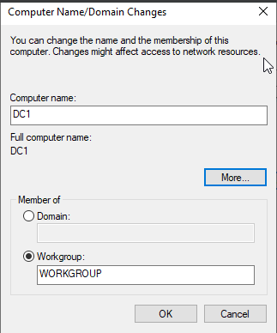

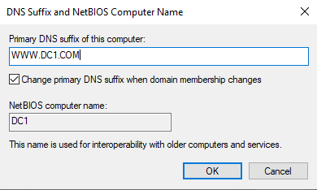

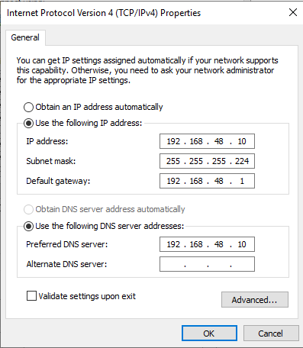

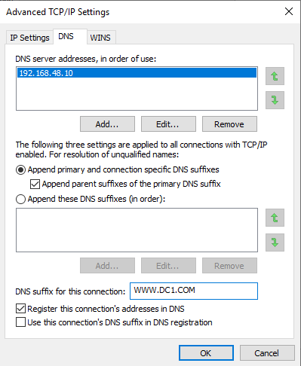

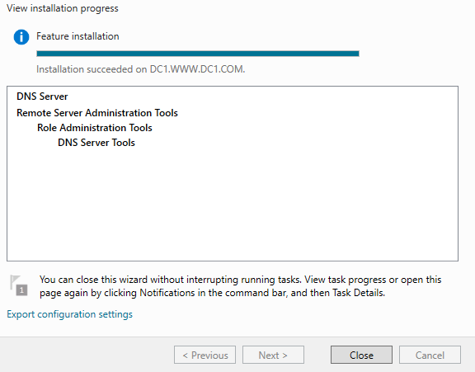

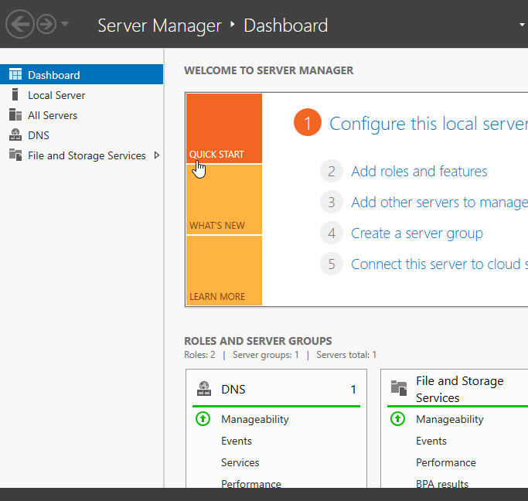
3.2 Create and Configure Active Directory for Company X at Head Office

Active Directory Domain Services (AD DS) was installed through Server Manager.
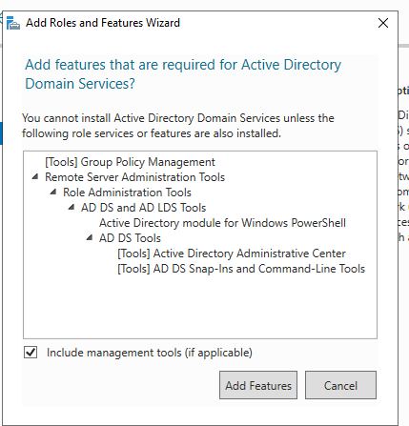

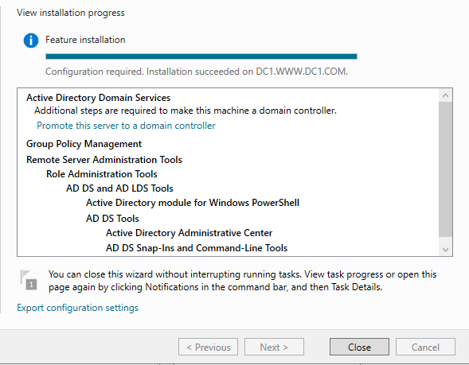

The server was then promoted to a Domain Controller by creating a new forest with the domain name:
technova.local

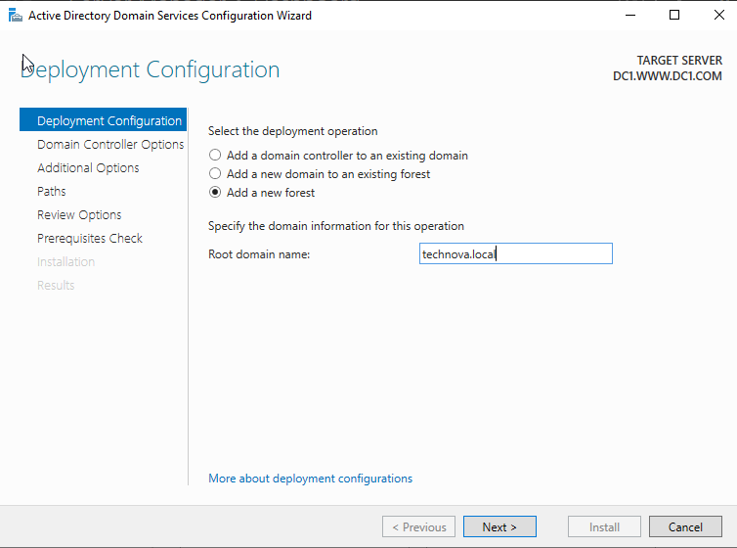

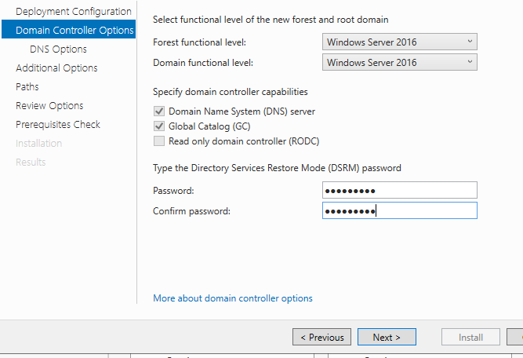
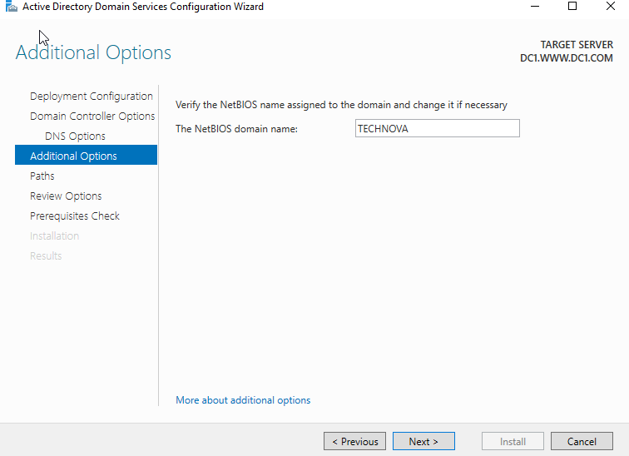
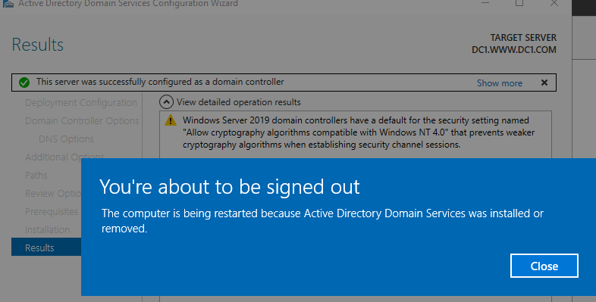
This domain is used to centrally manage users, computers, policies, and network resources within the organization. It allows centralized control of all network resources, making administration easier and more secure. It also ensures users can authenticate using a single login across the domain.

3.3 Create and configure Objects with Organizational Units
Active Directory was created and configured after promoting the server to a Domain Controller. The Active Directory environment allows centralized management of user accounts, organizational units, security policies, and network resources.
The following Organizational Units (OUs) were created:
- GAUTENG
- IT
- HR
- Procurement
Each OU contains users belonging to their respective departments. Active Directory Users and Computers (dsa.msc) was used to manage users and OUs.
Organizational Units were created to separate departments within the company structure. User accounts were created inside each OU according to departmental roles.
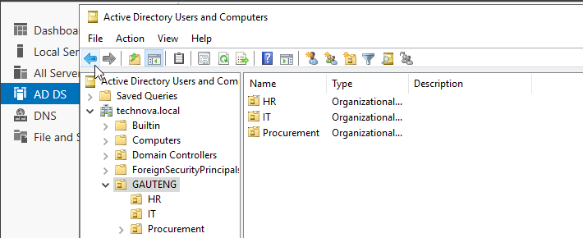

The following users were created:
HR Users
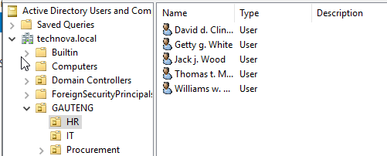

IT Users
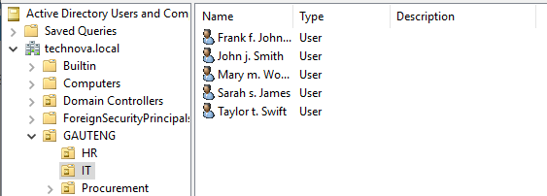

Procurement Users
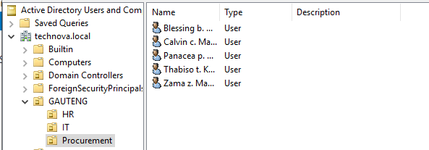

3.4 Create and configure Remote Desktop Connection between Server and Client Machine.
Remote Desktop was enabled on the server to allow remote administration. A client machine running Windows 10 was connected to the domain:
The Remote Desktop connection was tested using: mstsc
IT department users were successfully able to remotely connect to the server using their domain credentials.

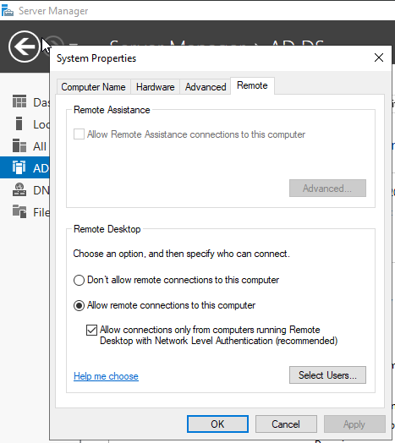
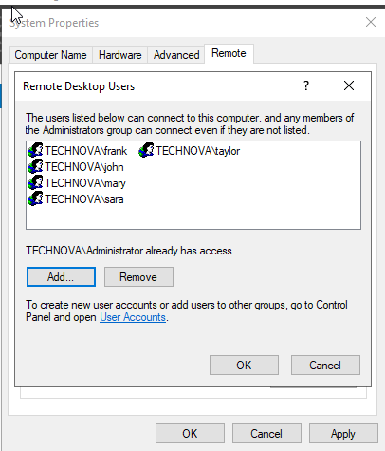

Assigned an IP address to the client’s machine.
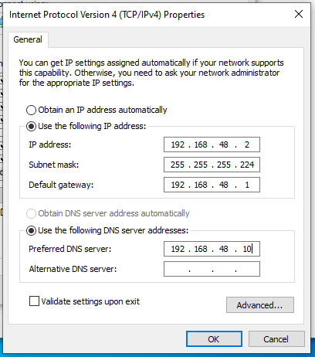
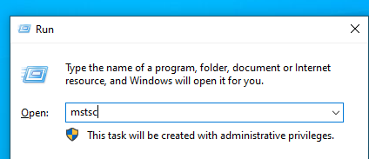

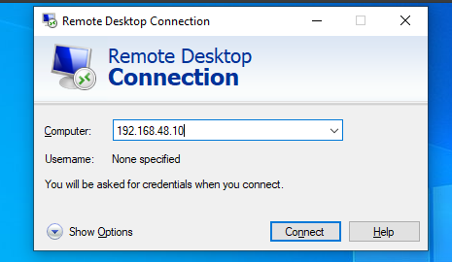

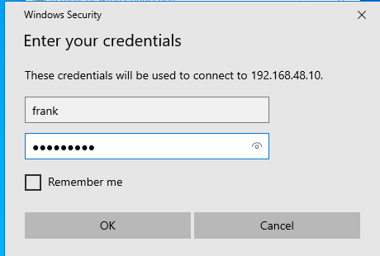

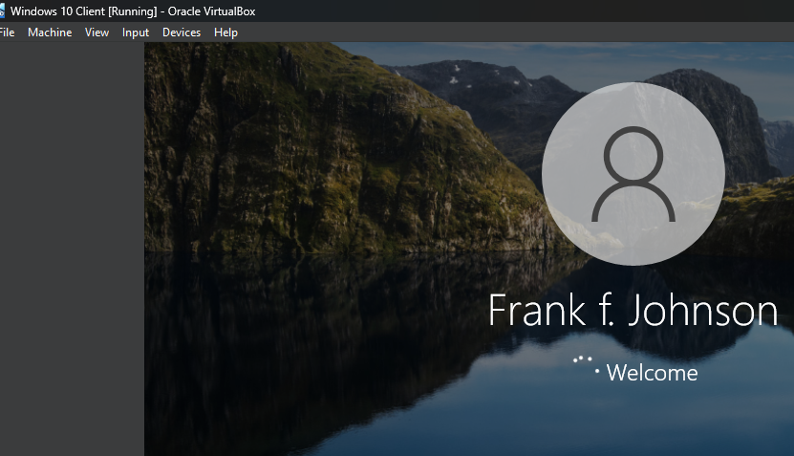

This setup enables IT administrators to remotely manage the server and assist users without physically accessing the machine.

3.5 Configure User Access Permissions
Group Policy Objects (GPOs) were implemented to enforce security and access rules across departments.

a. IT Department
Users in the IT department were allowed to:
- log into both the server and client machines,
- use Remote Desktop services,
- and access administrative network resources.

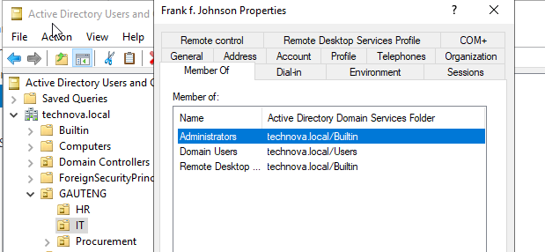

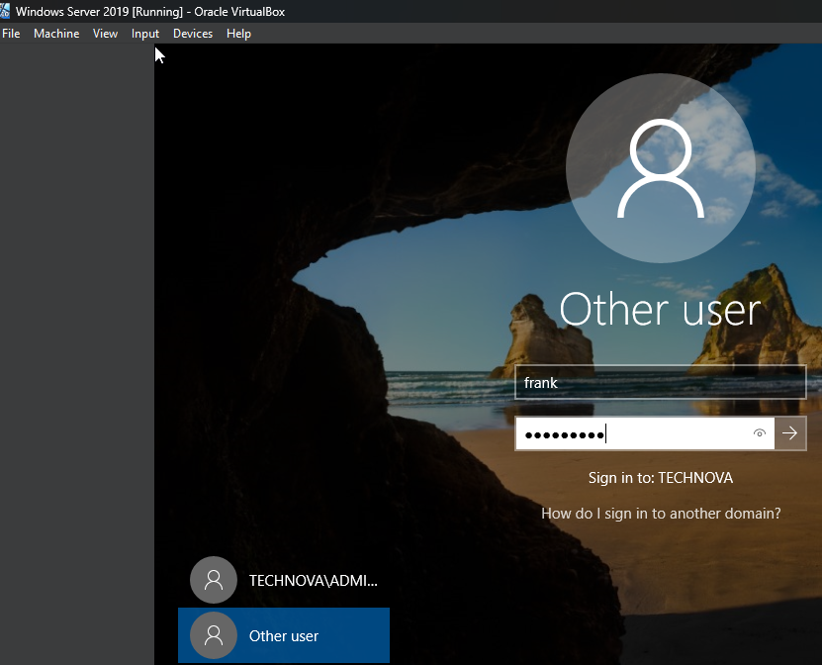
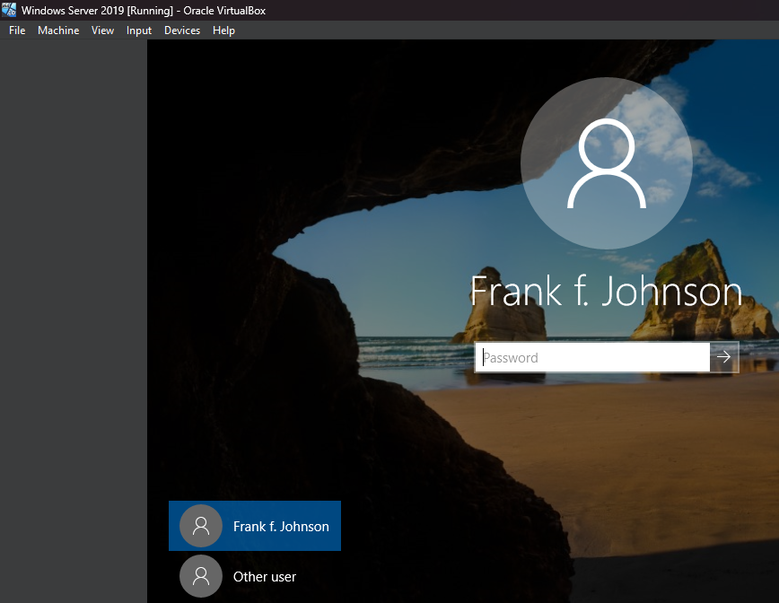





b. HR Department
HR users were:
- allowed to log into client machines only,
- assigned dedicated home drives (H: drive) for storing work files,
- restricted from logging into the server.
- This was enforced using User Rights Assignment in Group Policy:
- Deny log on locally
- Deny log on through Remote Desktop Services.

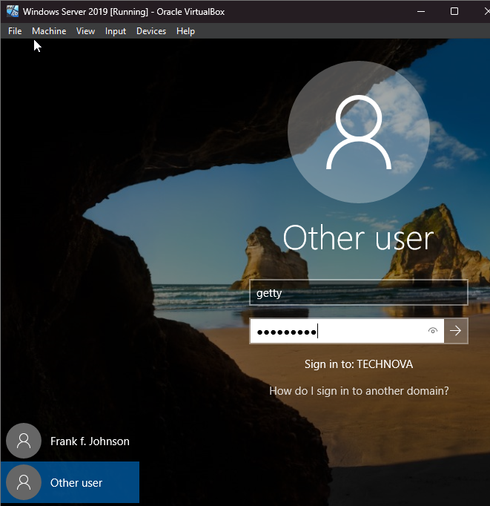
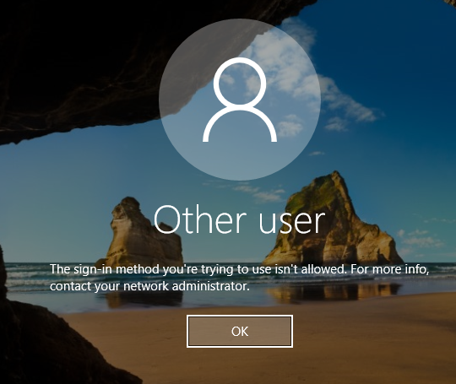
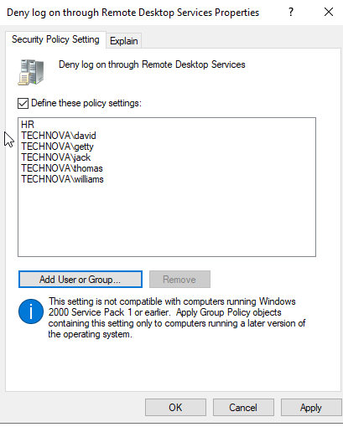

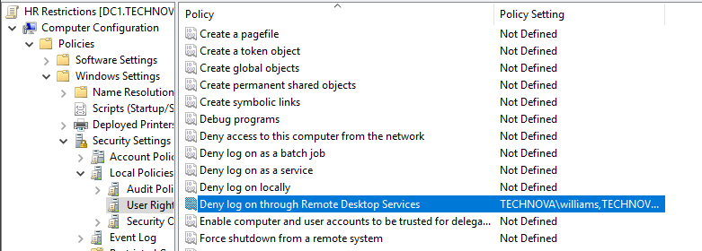

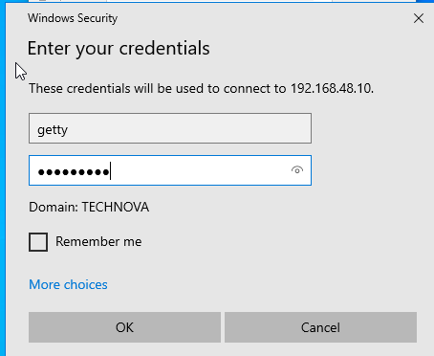
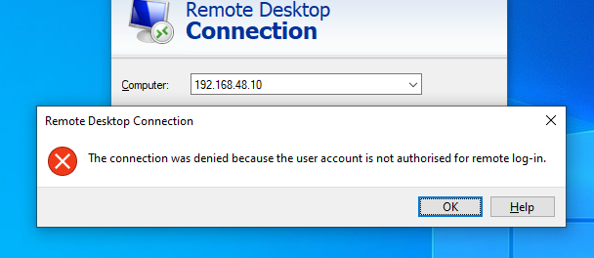

c. Employees in the HR department should have dedicated home drives to store their work files.
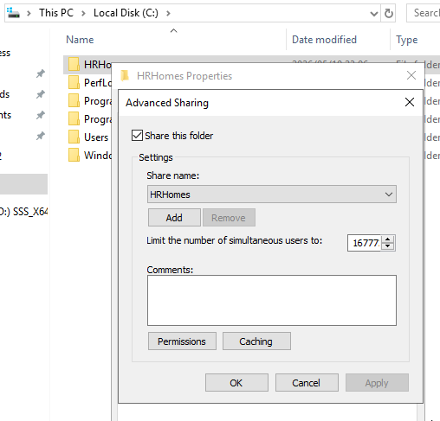

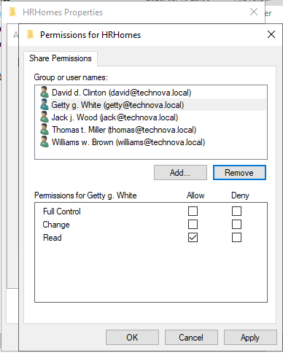

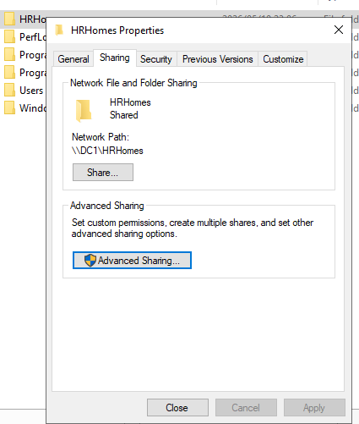
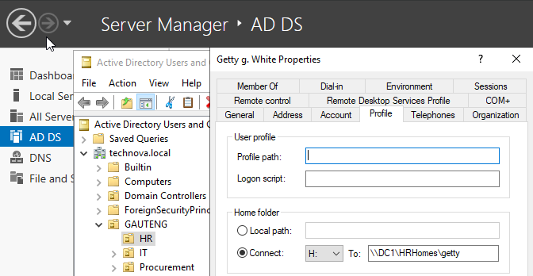

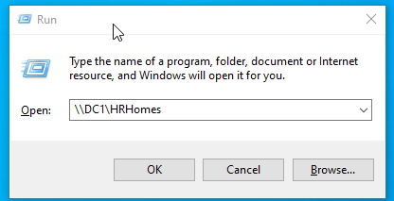

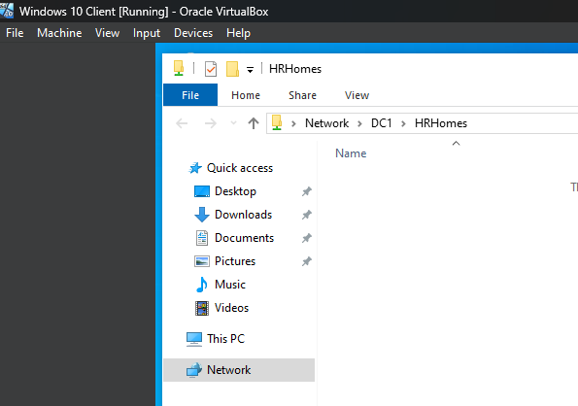

d. Procurement Department
Procurement users were:
- denied access to the server,
- restricted from using the “Run” command,
- and prevented from viewing “My Network Places” on the desktop through Group Policy settings.

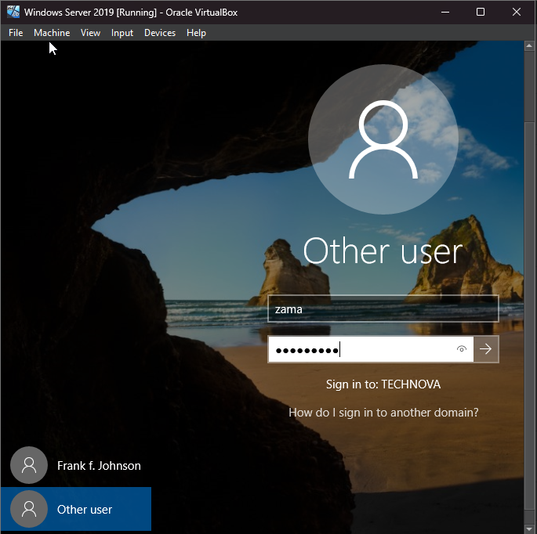
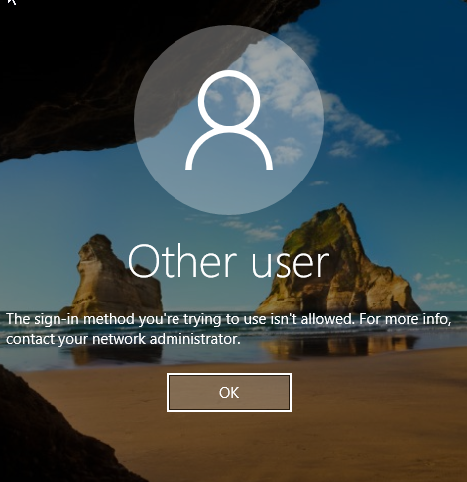

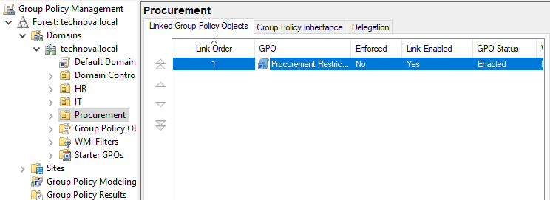

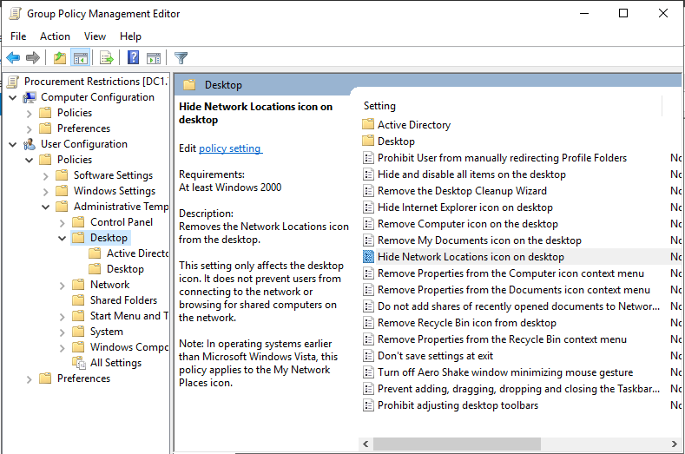
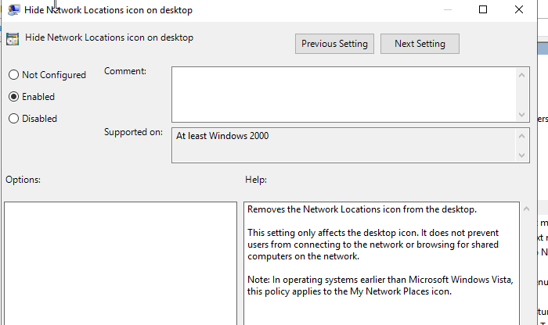

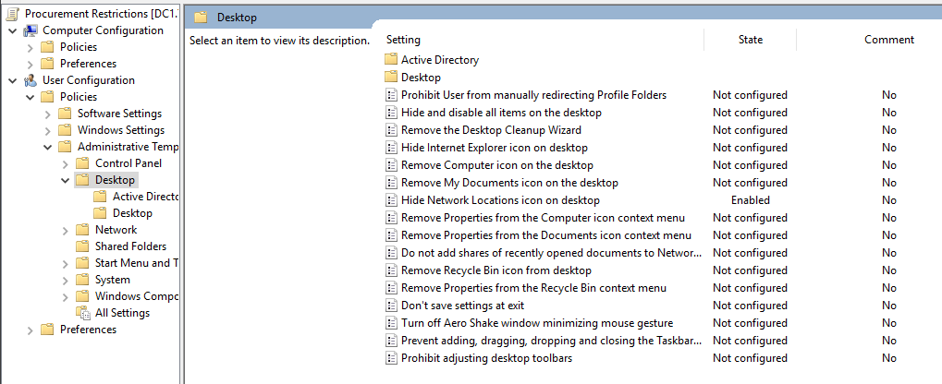

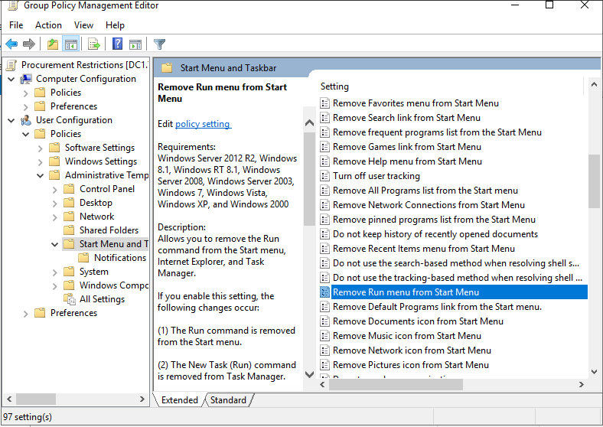

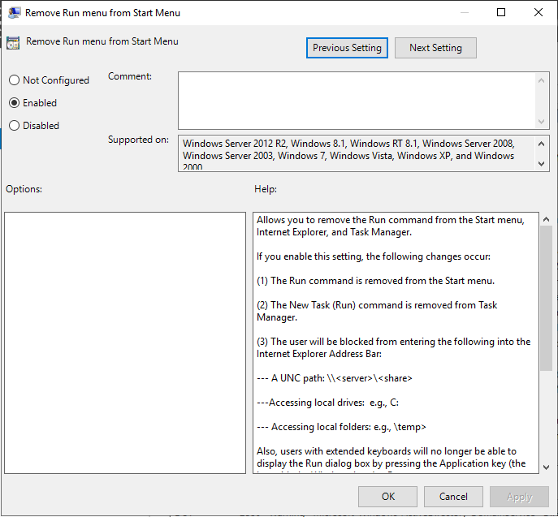

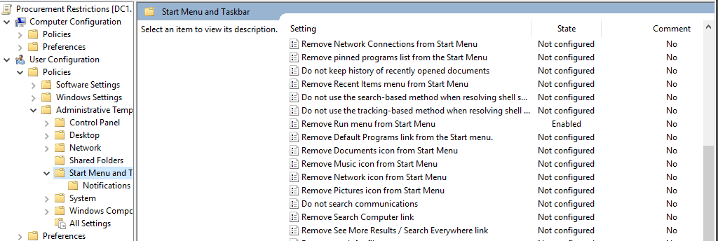

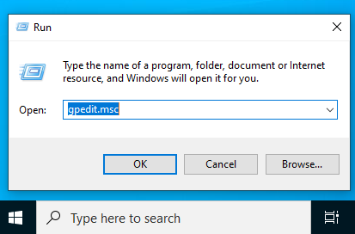
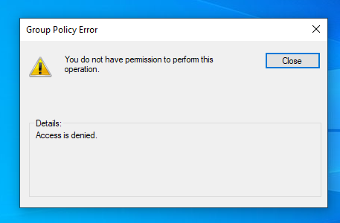

These policies ensure that Procurement users have limited access to system tools and network navigation features, improving security and reducing misuse.

Question 4

References
- CompTIA Network study guide : EXAM N10-008(Lammle,T.(2021))
- Microsoft.(2023).Active Directory Domain Services overview.Microsoft Learn
https://learn.microsoft.com/en-us/windows-server/identity/ad-ds/get-started/virtual-dc/active-directory-domain-services-overview
3.Tittel,E & Lindros,K(2022).Windows Server 2019 & 2022:administration fundamentals(3rd edition).Packet.
4.Tulloch,M.(2021).Introducing Windows Server 2019.Microsoft Press.
5. Computer Network(CN1F05D-Introduction to Networks v7.0 (ITN)) Cisco Notes
6. Some AI Tools(ChatGPT , Claude, Grok).
7. Cisco Networking Academy: "Introduction to Networks (CCNAv7) Course Booklet"
8. CompTIA Network+ Study Guide.
9. RFC 1918 (IETF): "Address Allocation for Private Internets"

